University
gas turbine stand and instrumentation

Chantel Flores
William Rektorik
Orlando Rodriguez

Faculty Advisor: Isaac Choutapalli Ph.D.
Faculty Co-Advisor: Robert Jones Ph.D.

University of Texas Rio Grande Valley
Senior Design I

Contents

ABSTRACT 5
Problem 6
Solution 6
Impact 7
Goals and Objectives 7
Market Research 7
Competitive Products 9
Needs & Wants & Constraints 9
Needs 9
Wants 10
Constraints 10
QFD 11
Functional Decomposition 16
Selection Process 16
Final Selection of all Sub-Functions 17
Final Design 23
Design Embodiment 24
Frame 25
Engine mount and force analysis rail system 26
Pitot tube traversing system 28
Engineering Calculations 31
Nomenclature 31
Vibration Analysis 32
FEA, Modal Analysis 33
FEA, Deformation of Frame 33
Zero – Order Uncertainty 35
Fatigue 40
Deflection of Pitot Traversing Rod 37
Deflection of Pitot Tube 38
Sliding Force 39
Manufacturing Process 41
Design for Safety 41
Design for Manufacturability 41
Failure Mode Engineering Analysis 41
Bill of Materials 43
Engineering Economics 45
Summary 46
References 47

List of Tables

Table 1: Quality Function Deployment 11
Table 2: Needs and Wants 12
Table 3: Comparative Company Analysis 13
Table 4 : Engineering Specifications 14
Table 5 : QFD Technical Evaluation 15
Table 6 : Determination of Weight of Engine Mount Design Constraint 18
Table 7 : Determination of Normalized Scores for Engine Mount Concept Variants Relative to Cost 18
Table 8 : Determination of Normalized Scores for Engine Mount Concept Variants Relative to Accuracy 18
Table 9 : Determination of Normalized Scores for Engine Mount Concept Variants Relative to Reliability 19
Table 10 : Determination of Normalized Scores for Engine Mount Concept Variants Relative to Damping 19
Table 11 : Final Selection of Concept Variant for Engine Mount 19
Table 12 : Determination of Weight of Instrumentation Design Constraints 20
Table 13 : Determination of Normalized Scores for Instrumentation Concept Variants Relative to Cost 20
Table 14 : Determination of Normalized Scores for Instrumentation Concept Variants Relative to Accuracy 20
Table 15 : Determination of Normalized Scores for Instrumentation Concept Variants Relative to Reliability 21
Table 16 : Final Selection of Concept Variant for Instrumentation 21
Table 17 : Determination of Weight of Structure Design Constraints 21
Table 18 : Determination of Normalized Scores for Structure Concept Variants Relative to Cost 22
Table 19 : Determination of Normalized Scores for Structure Concept Variants Relative to Aesthetics 22
Table 20 : Determination of Normalized Scores for Structure Concept Variants Relative to Safety 22
Table 21 : Determination of Normalized Scores for Structure Concept Variants Relative to Mobility 23
Table 22 : Determination of Normalized Scores for Structure Concept Variants Relative to Access 23
Table 23 : Final Selection of Concept Variant for Structure 23
Table 24: Ranking of failure mode 39
Table 25 : Ranking of Failure mode action 1 40
Table 26 : Bill of Materials 43
Table 27 : Retail cost calculations 45

List of Figures
Figure 1 : Market Size Proportion 8
Figure 2 : Final Design 24
Figure 3 : Structure 25
Figure 4 :Structure Drawings 25
Figure 5 : Engine Mount and Force Analysis Rail System 27
Figure 6 : Engine Mount and Force Analysis Rail System Drawing 28
Figure 7 : Pitot Tube Transversing System 29
Figure 8 : Pitot Tube Tranversing System Drawing 30
Figure 9: Engine Mount Force Analysis 32
Figure 10: Modal Analysis 33
Figure 11: Max Displacement of Frame 35
Figure 12 : Max Stress of Frame 35
Figure 13 : Pitot Traversing Deflection 37
Figure 14 : Pitot Tube Deflection 38
Figure 15 : Force Required for Table to Slide 39
Figure 16 :Fatigue Analysis 40

Abstract
The following report is for the design process of a test stand for a department owned turbojet engine. There are different test stand options available from companies like Turbine Technologies and GDJ Inc. These products are costly though and will not accommodate the turbojet that has already been acquired. Therefore this project is to design an affordable test stand for the Jetcat RX180 that can be used for scholastics and research. The process will begin with market research. That portion will endeavor to identify the competitors in the market and their products. The needs and wants of the customer will be assessed and comparisons will be performed on how the competitors satisfy them. A Quality Function Deployment (QFD) will be used to collate and analyze the market research data. Through this process a “sweet spot” will be developed for our product.
Once the sweet spot has been identified the concept development will begin. The process of functional decomposition will be utilized to isolate key sections of the design called sub-functions. Each of these sub-functions will undergo the sequence of brainstorming for concept variants, development of design constraints, and a selection process. The selection process will methodically compare each of the concept variants against each other in terms of the design constraints. The design with the highest score in the end will be chosen as the final selection for that sub-function. Once the selection process has been performed for each sub-function a prototype design can be said to be complete. That prototype will then be refined into the final design as minor adjustments are made because of the next section.
Subsequent to concept development will come the engineering analysis. The analysis be used to verify that the prototype design can function as intended in its operating environment. Key points of interest are vibration, fatigue, stress, and total error in the sensor measurement. Results from these analyses will be used to improve the design until a final design has been achieved.
Once the final design has been developed the engineering economics will begin. The costs associated with bringing this product to market will be investigated. Material costs and the number of employees needed for manufacture will all contribute to the final retail cost.

Problem
Engine test stands are primarily used to characterize and test engines which house several sensors along with data acquisition features that allow for the measurement of several physical variables of interest that characterize an engine. Often offered by an original equipment manufacturer (OEM) used as a part or subsystem for another company’s end-product facilitates for engines to be used in diverse operating regimes, which propose a wide range of configurations and capacities. Though with such large manufacturing capability, engine test stands are marginally cost exclusive. Turbine engine performance studies demand costly test stands for engine characterization and testing. This may impede for the ability to modify and build accordingly to personal and or individual preference and specifications. Correspondingly, results may be erroneous and imprecise as satisfying model availability supersedes particular need.

Solution
The proposed solution to remedy performance study costs is to autonomously design and build a test stand for an existing department owned gas turbine engine to reduce the cost of apparatus instrumentation. The desired variables of engine characterization are pressure, temperature, mass fuel flow, and thrust. Accompanying measurement sensors will be multiple thermocouples, a singular pitot tube, a fuel flowmeter and several load cells which must comply to a two percent margin of error for reliability and accuracy. Pursuing methods of quantitative disciplines will allow for the determining of the amount of miscalculation that may be accepted for the systems variability that will not impede on the integrity of the devices’ corresponding output. This strategy enables for low unit cost in comparison to available marketplace selections allowing for a marketable solution of affordability and accuracy for engine test stands.

Impact
The impact of such a proposed solution ranges between academic and industrial businesses. Such product affordability enables itself to be a competitive option for small jet engine manufacturers. Allowable engine operations may lease scholastic program usages for educational purposes such as do it yourself (DIY) professional packages to academic curriculum enhancements. Such market place motivations influence the newly proposed test engine stand for research and development (R&D). The significant effect of such an inexpensive means for engine characterization is for the promotion for the continuation of research in the Aerodynamics and Propulsion Laboratory at the University of Rio Grande Valley along with other cross disciplinary engineering workrooms and studies.

Goals and Objectives
The aims of such a senior design endeavor is to develop an instrumented gas turbine test stand for university research to enable the understandings of engine performance and opportunity improvement. This develops learning prospects for students to understand the limits and capabilities of a jet turbine engine. The intention is to instrument real time systems to measure process parameters for data analyzation to classify the system in accordance with theory to enable for opportunities for performance enhancement. The objective is to provide a precision test stand at a low cost for scholastic and research usage.

Market Research
Systematical gathering and organizing marketing research yielded three target manufacturers of test stands: P.A. Hilton, Turbine Technologies and GDJ. This information provided the market need and market size along with information used to identify and define marketing opportunities and difficulties. P.A. Hilton is a recognized market leader within the disciplines of Thermodynamics, Refrigeration, Air Conditioning, Combustion, Propulsion, Fluid Mechanics, and Heat Transfer with research continuation in the fields of Compressible Flow, Aerodynamics, Renewable Energy, Engine Tests, as well as Computerized Data Acquisition Systems. P.A Hilton is world-renowned in engineering teaching equipment making great strides in product quality, long lasting durable teaching products along with providing a high standard of after-sales support. Turbine Technologies is a manufacturer of educational laboratory equipment offering engineering and technical students unique learning opportunities across a multitude of disciplines supporting educational output objectives in science, technology, engineering and math (STEM). GDJ Inc. manufactures laboratory-grade equipment that encompasses all principles of engineering with reputable accuracy.
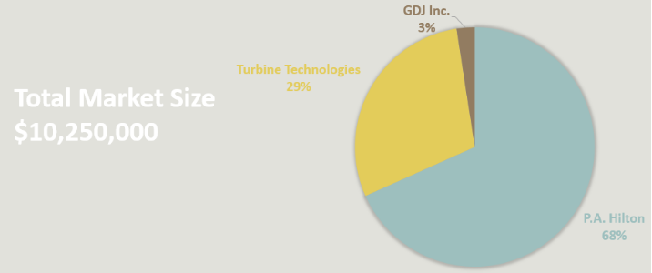
Figure 1 : Market Size Proportion
The total market size of all three manufactures contribute to $10,250,000 yearly. P.A. Hilton dominates the market size with a staggering share of 68%. Turbine Technologies contributes nearly a third to the overall market size with a figure of 29%, leaving GDJ outsourced with a mere 3% share of the total market size. This graphical illustration provides the quantitative research in determining the qualitative examination necessary in order to main competitiveness over competitors.

Competitive Products
P.A. Hilton offer test stands with integrated pulse and ramjets. These test stands are specifically aimed for education purposes and come with multiple sensors pre-installed priced at $72,500.
Turbine Technologies include the National Instrumented Data Acquisition system LabView, providing custom virtual instrument panel with an accompanied gas turbine engine priced anywhere from $60,495 to $121,095.
GDJ Inc manufactures fully integrated test stands for reciprocating and gas turbine engines. These engine test stands include an already integrated installed engine, with a corresponding base price of $68,500.

Needs & Wants & Constraints

Needs
The following below are the requisites for product functionality for the gas turbine instrumented engine test stand needed for consumer satisfaction.
- Accurate
- A critical assumption that the variation expected in the measurand will be less than two percent.
- Damping of vibration
- It is vital for the minimization of unwanted vibration to reduce equipment faults.
- Durable
- Essential to withstand an assortment of damages as the implementation of this device is anticipated for prolonged department usage.
- User friendly
- Enabling such a system to be easy to use and understand will accommodate various handlers.

Wants
Provided below are the various consumer wants of the products and services specific to the gas turbine engine instrumented test stand.
- Affordability
- Deliver a competitive cost.
- Modularity
- Provide an extent in which the system components may be separated and recombined.
- Aesthetically Appealing
- Offer an attractive marketable product.

Constraints
The following limitations are the restraints for the gas turbine engine instrumented test stand.
- Cost
- Provide a retail cost less than $40,000
- Safety
- Ensure the protection of the consumer as well as the product from danger, risk, or injury.
- Precision
- Adapted for accuracy and exactness.
- Measurement Parameters
- Manufactured components and obtained apparatuses comply with engine range.

QFD
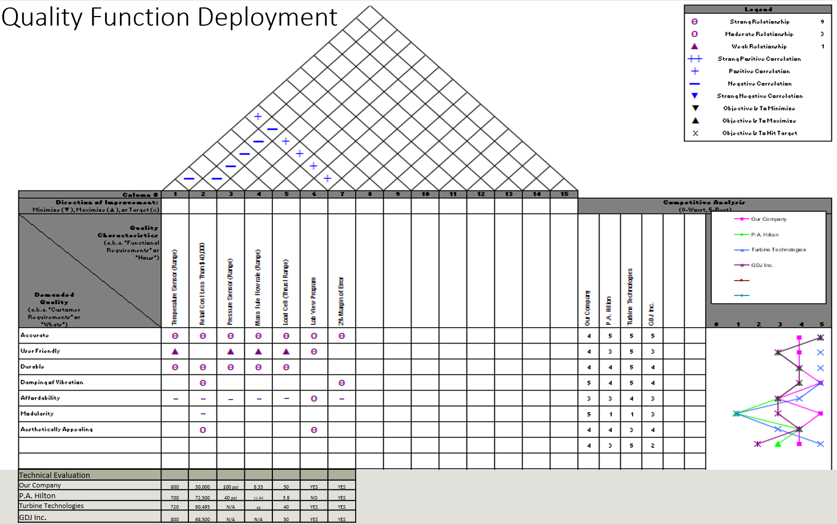
Table 1: Quality Function Deployment
The Quality Function Deployment (QFD) has 4 sections of interest. These sections are the needs and wants, the competitive analysis, the engineering specifications, and the technical evaluation. Each of these sections is to be analyzed individually in this section.
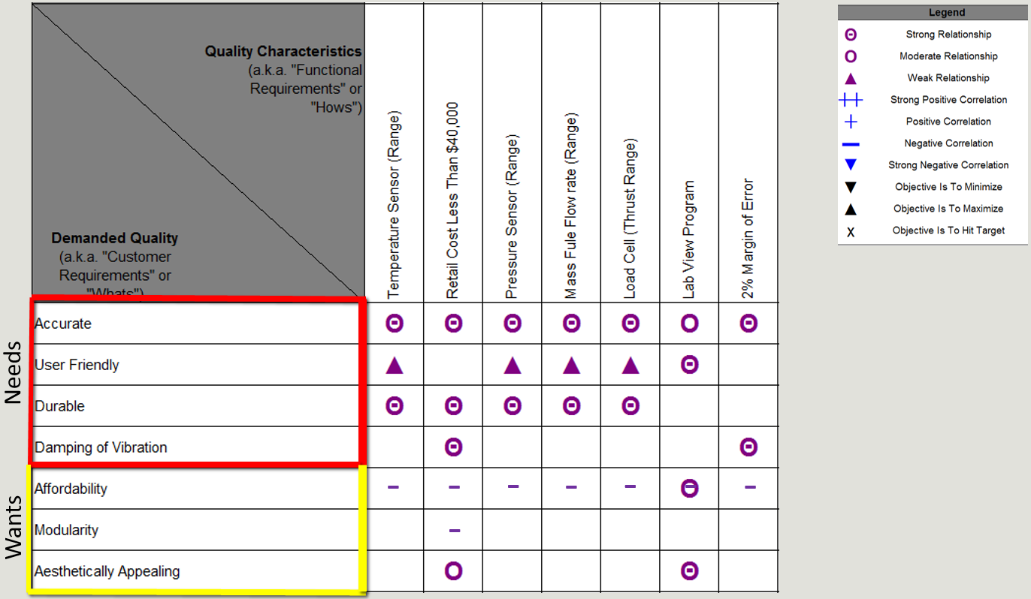
Table 2: Needs and Wants
The needs and wants section as seen above compares the customers indicated needs and wants to the engineering specifications. The engineering specifications are quantifiable factors that are to be used to satisfy the customer’s needs and wants. In this instance it can be seen that accuracy has a strong or moderate relationship with all the engineering specifications. User friendliness is most strongly related to the quality of the Lab View Program. Durability is strongly related to the quality of the sensors along with the manufacturing cost. Vibration damping is related to the margin of error and the manufacturing cost. Affordability is negatively related to everything except for the Lab View Program. Modularity is negatively related to the manufacturing cost. Aesthetics is related only to the manufacturing cost and the lab view program.

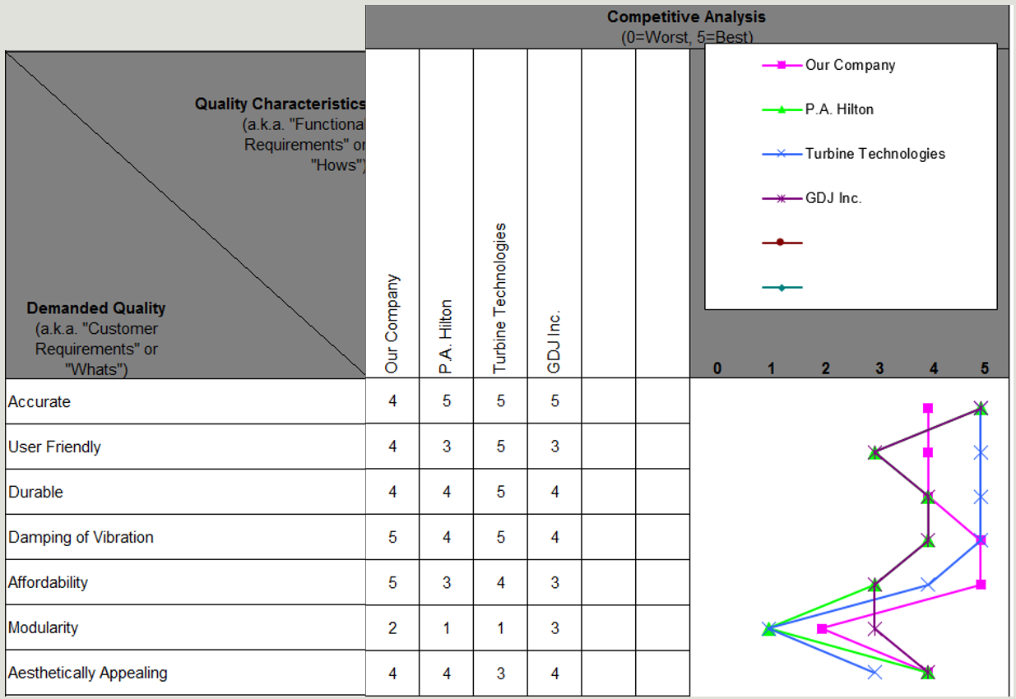
Table 3: Comparative Company Analysis
The comparative company analysis as seen above relates how well our company and our competitors satisfy the needs and wants of the customer. Our three competitors analyzed are P.A Hilton, Turbine Technologies, and GDJ Inc. Turbine Technologies satisfies all of the customers needs with maximum quality. While our company falls just below Turbine Technologies in satisfying the needs, it stays equal to or above our other competitors. Where our company outclasses all our competitors is in affordability. No other competitor can come close to the low cost of our product.
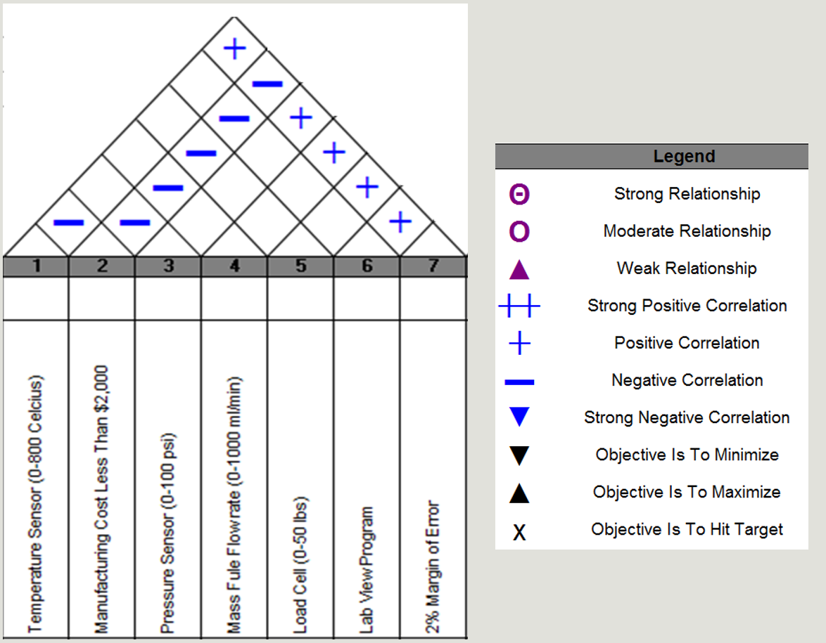
Table 4 : Engineering Specifications
The engineering specifications section, as shown above, relates each specification to the others to determine if there is exists strong or weak correlations that can be either positive or negative. Notable in this section is that manufacturing cost is negatively correlated to all other engineering specifications. The margin of error is positively correlated to all specifications except the cost.
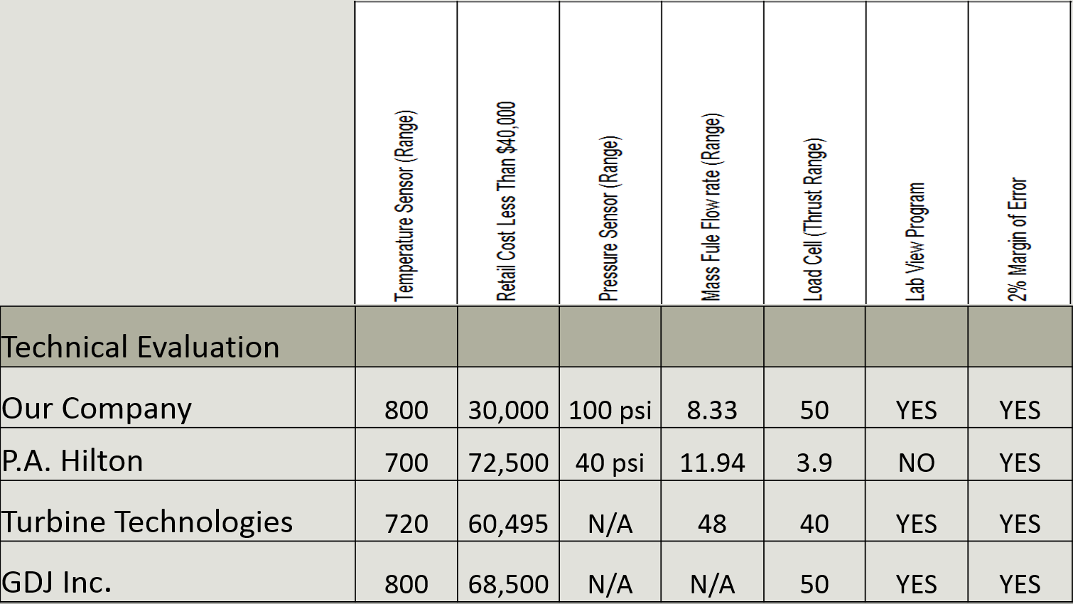
Table 5 : QFD Technical Evaluation
The technical evaluation as seen above compares our company to our competitors in the category of the engineering specification. Noteworthy about this table is that all companies have very similar values except when it comes to retail cost. As was seen earlier in the comparative company analysis our company has the lowest retail cost.

Functional Decomposition
To better facilitate division of labor a functional decomposition was performed on the product. Three sub-functions were identified as being part of the larger system.
Sub-function 1 was selected to be the engine mount. Within this are three sub-sub-functions. These are the cradle to which the turbine is directly attached, the measurement of thrust, and a damping system.
Sub-function 2 was selected to be the instrumentation for the test stand. The instrumentation includes temperature measurement, pressure measurement, measurement of the rate at which the fuel is being consumed, and the data acquisition system.
Sub-function 2 was selected to be the structure. The structure includes three sub-sub-functions. These are the frame and table surface of the test stand, a wheel system that allows the wheels to be folded up and secured during engine operation, and a traversing system for the Pitot tube.

Selection Process
Concept variants were developed by the team members for each of the three sub-functions in the functional decomposition. The selection process was performed with the input of all team members. For each sub-function constraints were first chosen. These constraints were what the team decided were the most important design factors that had to be satisfied for each sub-function. Once constraints were selected they were compared against each other as to their importance on a scale of 0-6. This gave each constraint a weighting factor. Next the concept variants were compared against each other in terms of how well they satisfied each of the constraints. From this a normalized score was obtained from each concept variant relative to each constraint. These normalized scores were multiplied by the weight of their respective constraints and summed for a final score. The concept variant with the highest final score became the final design selection.

Final Selection of all Sub-Functions
Sub-function 1 was determined to have 4 constraints. These were cost, accuracy, reliability, and damping. Accuracy was determined to be the most important constraint, with a weight of 0.333. Cost was determined to be the least important constraint, with a weight of 0.194. The concept variants developed for this sub-function were a rail, linkage, and a force plate. The rail and linkage were found to be the most cost effective. The rail and force plate were the most accurate. The force plate was the most reliable. The rail had the best damping. The winning concept for the engine mount sub-function was the rail.
Sub-function 2 was determined to have cost, accuracy, and reliability as the concept variants. Accuracy and reliability were determined to be the most important constraints, each with a weight of 0.444. For this sub-function the analysis was performed with an eye towards which instrumentation should be of the best quality. Pressure transducers, thermocouples, load cells, and fuel flow meters are all necessary for our design. This process was to determine which of those instruments needed to be the best. For each of the constraints the pressure transducers and load cells tied for the most important sensor type. The most important sensors were therefore chosen as the pressure transducers and the load cells.
Sub-function 3 was determined to have cost, aesthetics, safety, mobility, and access as the constraints. Safety was the most important constraint with a weight of 0.317. The concept variants were an unenclosed structure, a hutch shaped enclosure, and a fish tank shaped enclosure. The unenclosed structure was identified as the most cost effective solution. The hutch was best in aesthetics. The hutch and fish tank variants tied for most safe. The fish tank was found to have the best access for maintenance and experiment setup. The winning concept for the structure was found to be the fish tank.

Table 6 : Determination of Weight of Engine Mount Design Constraint
Engine Mount/Thrust Measurement
 | Cost | Accuracy | Reliability | Damping | Row Sum | Norm. Score
Cost |  | 1 | 2 | 3 | 6 | 0.167
Accuracy | 5 |  | 3 | 4 | 12 | 0.333
Reliability | 4 | 3 |  | 4 | 11 | 0.306
Damping | 3 | 2 | 2 |  | 7 | 0.194
Col. Score | 12 | 6 | 7 | 11 | 36 | 1

Table 7 : Determination of Normalized Scores for Engine Mount Concept Variants Relative to Cost
Cost
 | Rail | Linkage | Force Plate | Row Sum | Norm. Score
Rail |  | 3 | 5 | 8 | 0.444
Linkage | 3 |  | 5 | 8 | 0.444
Force Plate | 1 | 1 |  | 2 | 0.111
Col. Score | 4 | 4 | 10 | 18 | 1.000

Table 8 : Determination of Normalized Scores for Engine Mount Concept Variants Relative to Accuracy
Accuracy
 | Rail | Linkage | Force Plate | Row Sum | Norm. Score
Rail |  | 4 | 3 | 7 | 0.389
Linkage | 2 |  | 2 | 4 | 0.222
Force Plate | 3 | 4 |  | 7 | 0.389
Col. Score | 5 | 8 | 5 | 18 | 1

Table 9 : Determination of Normalized Scores for Engine Mount Concept Variants Relative to Reliability
Reliability
 | Rail | Linkage | Force Plate | Row Sum | Norm. Score
Rail |  | 4 | 2 | 6 | 0.333
Linkage | 2 |  | 2 | 4 | 0.222
Force Plate | 4 | 4 |  | 8 | 0.444
Col. Score | 6 | 8 | 4 | 18 | 1

Table 10 : Determination of Normalized Scores for Engine Mount Concept Variants Relative to Damping
Damping
 | Rail | Linkage | Force Plate | Row Sum | Norm. Score
Rail |  | 4 | 4 | 8 | 0.444
Linkage | 2 |  | 3 | 5 | 0.278
Force Plate | 2 | 3 |  | 5 | 0.278
Col. Score | 4 | 7 | 7 | 18 | 1

Table 11 : Final Selection of Concept Variant for Engine Mount
Engine Mount/ Thrust
 | Cost | Accuracy | Reliability | Damping | Score
Rail | 0.0741 | 0.1296 | 0.1019 | 0.0864 | 0.392
Linkage | 0.0741 | 0.0741 | 0.0679 | 0.0540 | 0.270
Force Plate | 0.0185 | 0.1296 | 0.1358 | 0.0540 | 0.338
Decision |  |  |  |  | Rail

Table 12 : Determination of Weight of Instrumentation Design Constraints
Instrumentation
 | Cost | Accuracy | Reliability | Row Sum | Norm. Score
Cost |  | 1 | 1 | 2 | 0.111
Accuracy | 5 |  | 3 | 8 | 0.444
Reliability | 5 | 3 |  | 8 | 0.444
Col. Score | 10 | 4 | 4 | 18 | 1.000

Table 13 : Determination of Normalized Scores for Instrumentation Concept Variants Relative to Cost
Cost
 | Pressure Ducers | Thermocouples | Load Cell | Row Sum | Norm. Score
Pressure Ducers |  | 5 | 3 | 8 | 0.444
Thermocouples | 1 |  | 1 | 2 | 0.111
Load Cell | 3 | 5 |  | 8 | 0.444
Col. Score | 4 | 10 | 4 | 18 | 1

Table 14 : Determination of Normalized Scores for Instrumentation Concept Variants Relative to Accuracy
Accuracy
 | Pressure Ducers | Thermocouples | Load Cell | Row Sum | Norm. Score
Pressure Ducers |  | 4 | 3 | 7 | 0.389
Thermocouples | 2 |  | 2 | 4 | 0.222
Load Cell | 3 | 4 |  | 7 | 0.389
Col. Score | 5 | 8 | 5 | 18 | 1

Table 15 : Determination of Normalized Scores for Instrumentation Concept Variants Relative to Reliability
Reliability
 | Pressure Ducers | Thermocouples | Load Cell | Row Sum | Norm. Score
Pressure Ducers |  | 5 | 3 | 8 | 0.444
Thermocouples | 1 |  | 1 | 2 | 0.111
Load Cell | 3 | 5 |  | 8 | 0.444
Col. Score | 4 | 10 | 4 | 18 | 1

Table 16 : Final Selection of Concept Variant for Instrumentation
Engine Mount/ Thrust
 | Cost | Accuracy | Reliability | Score
Pressure Ducer | 0.0494 | 0.1728 | 0.1975 | 0.420
Thermocouple | 0.0123 | 0.0988 | 0.0494 | 0.160
Load Cell | 0.0494 | 0.1728 | 0.1975 | 0.420
Decision |  |  |  | P. Ducer & L.C.

Table 17 : Determination of Weight of Structure Design Constraints
Structure
 | Cost | Aesthetics | Safety | Mobility | Access | Row Sum | Norm. Score
Cost |  | 3 | 1 | 4 | 3 | 11 | 0.183
Aesthetics | 3 |  | 1 | 2 | 2 | 8 | 0.133
Safety | 5 | 5 |  | 5 | 4 | 19 | 0.317
Mobility | 2 | 4 | 1 |  | 3 | 10 | 0.167
Access | 3 | 4 | 2 | 3 |  | 12 | 0.200
Col. Score | 13 | 16 | 5 | 14 | 12 | 60 | 1.000

Table 18 : Determination of Normalized Scores for Structure Concept Variants Relative to Cost
Cost
 | Unenclosed | Hutch | Fish Tank | Row Sum | Norm. Score
Unenclosed |  | 4 | 4 | 8 | 0.444
Hutch | 2 |  | 3 | 5 | 0.278
Fish Tank | 2 | 3 |  | 5 | 0.278
Col. Score | 4 | 7 | 7 | 18 | 1

Table 19 : Determination of Normalized Scores for Structure Concept Variants Relative to Aesthetics
Aesthetics
 | Unenclosed | Hutch | Fish Tank | Row Sum | Norm. Score
Unenclosed |  | 2 | 2 | 4 | 0.222
Hutch | 4 |  | 4 | 8 | 0.444
Fish Tank | 4 | 2 |  | 6 | 0.333
Col. Score | 8 | 4 | 6 | 18 | 1

Table 20 : Determination of Normalized Scores for Structure Concept Variants Relative to Safety
Safety
 | Unenclosed | Hutch | Fish Tank | Row Sum | Norm. Score
Unenclosed |  | 1 | 1 | 2 | 0.111
Hutch | 5 |  | 3 | 8 | 0.444
Fish Tank | 5 | 3 |  | 8 | 0.444
Col. Score | 10 | 4 | 4 | 18 | 1

Table 21 : Determination of Normalized Scores for Structure Concept Variants Relative to Mobility
Mobility
 | Unenclosed | Hutch | Fish Tank | Row Sum | Norm. Score
Unenclosed |  | 3 | 3 | 6 | 0.333
Hutch | 3 |  | 3 | 6 | 0.333
Fish Tank | 3 | 3 |  | 6 | 0.333
Col. Score | 6 | 6 | 6 | 18 | 1

Table 22 : Determination of Normalized Scores for Structure Concept Variants Relative to Access
Access
 | Unenclosed | Hutch | Fish Tank | Row Sum | Norm. Score
Unenclosed |  | 5 | 4 | 9 | 0.5
Hutch | 1 |  | 2 | 3 | 0.167
Fish Tank | 2 | 4 |  | 6 | 0.333
Col. Score | 3 | 9 | 6 | 18 | 1

Table 23 : Final Selection of Concept Variant for Structure
Structure
 | Cost | Aesthetics | Safety | Mobility | Access | Row Sum
Unenclosed | 0.08 | 0.0296 | 0.0352 | 0.0556 | 0.1 | 0.302
Hutch | 0.05 | 0.0593 | 0.1407 | 0.0556 | 0.03333 | 0.340
Fish Tank | 0.05 | 0.0444 | 0.1407 | 0.0556 | 0.06667 | 0.358
Decision |  |  |  |  |  | Fish Tank

Final Design

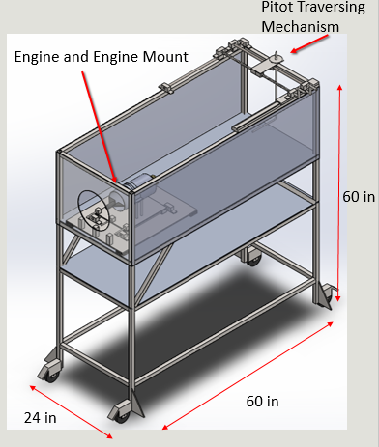
Figure 2 : Final Design

Design Embodiment
The final design consists of 3 major subsystems.

Frame
Figure 3 : Structure
Figure 4 : Structure drawings
The fame measuring 5ft in height, 2ft in width and 5 ft. in length is made of 1in.X 1in. square tubing.. The total height of the frame was determined to be 5ft tall to allow for students conduction experiments to be able to reach the traversing pitot rack a top the structure. The upper most section of the frame will house the gas turbine engine and is enclosed by .25 in. plexi glass which will allow both viewing of experiments being conducted by the gas turbine engine and safety to the outside environment. The back end of the upper housing will not be enclosed by plexi glass to allow outgoing exhaust gas to freely out of the engine. Plexi with a hole cut out to allow for inflow air will be added to the front of the housing to ensure additional safety if a problem may arise. The bottom support beams allow for extra stability against tipping that is caused by the forward thrusting of the engine. The bottom supports also allowing for mounting of the wheel system that will prop down when the stand needs to be mobile and prop back up when the sand need to stay in place during experiments. Not depicted in the figure, another emergency stop button will be placed on the bottom supports to allow a quick “kick and stop” in the case of an emergency. The computer containing the LabVIEW program will be on a separate cart which will also contain an emergency stop. The lower most table will hold many instrumentation and wiring necessary for operation including a tank for holding kerosene.

Engine mount and force analysis rail system

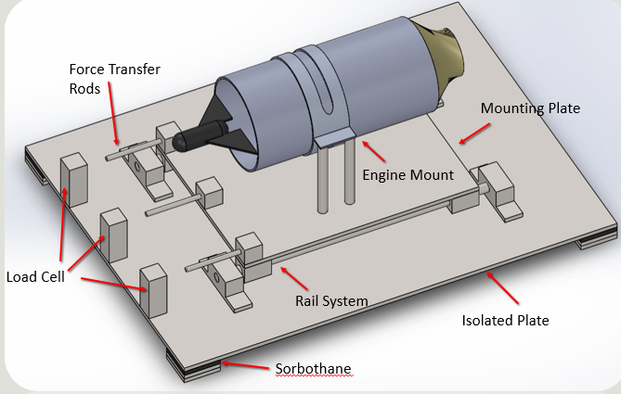
Figure 5 : Engine Mount and Force Analysis Rail System
Figure 6 : Engine Mount and Force Analysis Rail System Drawing
A rail system will be used to measure the trust of the engine using 3 load cells. The purpose of the three load cells is to reduce any moment that would cause false force readings. The turbine will be held by a given mount from the manufacture. The mount will be held down by 4, 4.5in high steel rods that will be bolted onto the mounting plate. The mounting plate is 13in by 10in and will set on 4 linear bearings as shown in the figure. The linear bearings will traverse along the 15in linear rods that are mounted along pillow blocks. The pillow blocks are mounted on a 24in by 18in plate that is isolated from the rest of the system by Sorbothane.

Pitot tube traversing system

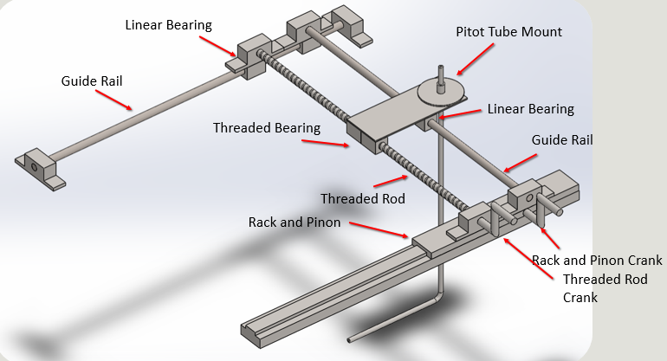
Figure 7 : Pitot Tube Traversing System
Figure 8 : Pitot Tube Traversing System Drawing
To measure pressure and velocity a pitot tube will be placed in back of the engine and will be able to traverse both with the outflow and lateral to the flow to capture the velocity profile of the exhaust gas. The pitot tube will move in the direction of the flow through a rack and pinon system. The rack and pinon system is mounted on one side of the frame while a linear bearing and linear rod wile act as the traversing mechanism on the other side of the frame. The rack and pinon system will be the driving force the moves the linear bearing along the linear rod. Connecting the rack and pinon system to the linear bearing and rod, which will create the movement lateral to the flow are two rods, one of which is a screw and the other which is a linear rod. The screw will go through a bolt, which when the screw is rotated, the bolt will traverse back and forward. The other rod as depicted, will help in the support of the pitot tube mount. The mount will be a single sheet of .25in steel that will sit atop the screw and the linear bearings. A hole will be drilled in the back end of the sheet where the pitot tube will be placed and held by a clamp.

Engineering Calculations

Nomenclature
X : Amplitude [m]
$m$ : Mass [kg]
$m_{0}$ : Unbalanced mass [kg]
$e$ : Eccentricity***

$r$ : Radius [m]
$ζ$: Damping ratio
$F_{0}$: Excitation force [kg]
$ω_{r}$: Rotational frequency [rad/s]
$$δ_{max} :Max displacement [in]$$
$$d :Diameter [in]$$
E $:Modulus [psi]$
$$I :Moment of inertia [{in}^{4}]$$
$$L :Length [in]$$
$$P :Force [lbs]$$

$$N :Normal force [lbs]$$
$$F :Force [lbs]$$
$$μ :Coefficient of static friction$$

$$W :Weight [lbs]$$
$$σ_{Axial} :Axial Stress [psi]$$
$$σ_{Bending} :Bending Stress [psi]$$
$$τ_{Shear}: Transverse Shear [psi]$$
$$σ_{E} : Von Mises [psi]$$

Vibration Analysis

With the turbine being a rotating mass, some vibration will occur causing an amplitude of the engine which with be transmitted to the rest of the stand. If there is enough vibration, it can greatly affect the accuracy of the instrumentation. To damp the vibration a rubber material called Sorbothane will isolate the engine and its mount from the rest of the stand. To ensure enough amplitude is damped through the Sorbothane, the following calculations were done.
F

Figure 9 : Engine Mount Force Analysis
$$X= \frac{m_{0}e}{m}\frac{r^{2}}{\sqrt{{(1-r^{2})}^{2}+{(2ζr)}^{2}}}$$

Where $F_{0}= m_{0}eω_{r}^{2}$
$$X= \frac{F_{0}}{ω_{r}^{2}m}\frac{r^{2}}{\sqrt{{(1-r^{2})}^{2}+{(2ζr)}^{2}}}$$

$$X= in$$
Using force of the engine due to torque, the damping constant of Sorbothane (50 duro, .25in thickness) and the spring constant of Sorbothane (50 duro, .25in thickness); it was found the Sorbothane would properly damp the system.

FEA, Modal Analysis
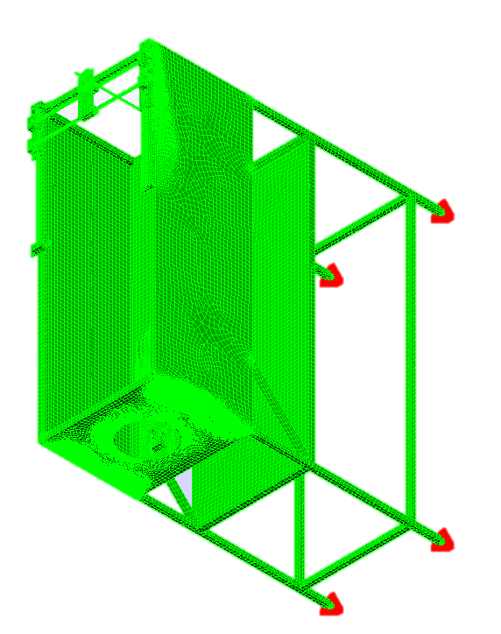

Figure 10: Modal Analysis

According to the documentation that was provided with the turbojet engine, the operating range is 32000-125000 rpm. As no revolving object is perfectly balanced we can assume that vibrations will occur as the compressor and turbine rotate. Converting the rpms to hertz gives a vibration range of 533Hz to 2083Hz for the engine. Verification needs to be performed on whether or not the structure will sympathetically vibrate within that operating range. To do this Finite Element software will be used. Several issues occurred during attempts to use Algor to perform this analysis. The first issue was getting the CAD model to fuse into a single piece and be recognized by Algor. That issue was solved, but currently the program is having issues with the mesh. This is preventing the analysis from going to completion. To correct this issue two methods will be used. First the mesh size will be increased. If that does not work then the model will be simplified until it will run.

FEA, Deformation of Frame
With the turbine creating 40lbs of thrust, deformation of the stand is of concern. The confirmation that the stand would hold up while in use is significant importance due to the required safety of the system. The following finite element analysis was done
- Load = 40lbs
- Element : Beams
- Boundary Condition : Fixed Feet
- Nodes : 28
- Material : Steel
Figure 11 : Max Displacement of Frame
Figure 12 : Max Stress of Frame
Max Displacement = .005in
Max Stress = 2.9 Kpsi
Using SolidWorks static simulation maximum displacement of the stand was found to be 0.005in and maximum stress was found to be 2.9kpsi. Both these results are within allowable safety ranges. With confidence, it was concluded the stand would withstand the force of the turbine.

Zero – Order Uncertainty
In the ideal measurement, the value assigned by the measurement would be the actual value of the physical variable intended to be measured. However, measurement errors bring on an uncertainty in the correctness of the value resulting from the measurement. While no general discussion of errors can be complete in listing, the elements contributing to error in a particular measurement, generalizations for error sources can be made to help in their identification such as the zero-order analysis. in every design, there is that initial stage where measurement system and its procedure is but a concept. Uncertainty analysis is used to assist in the selection of equipment and procedures based on their relative performance and even cost. The initial step in design-stage analysis is to determine the minimum uncertainty in the measured value that would result from each of the proposed measurement methods the measurement system consists of sensors and instruments each with their respective contributions to system uncertainty. Even when all errors are zero, the value of the measured must be affected by the ability to resolve the information given by the instrument.
$u_{d}=\sqrt{u_{0}^{2}+u_{c}^{2} }$ design stage uncertainty
$u_{0=±\frac{1}{2}resolution}$ interpolation error
$u_{c}$instrument errors
An arbitrary rule is to assign a numerical value to u_{o} of one-half of the instrument resolution with a probability of 95%.
The following calculations are the zero-order uncertainty analysis for the pressure transducer using the data acquisition devices resolution.
- Pressure Transducer
- Resolution:$u_{o}$= Interpolation Error= $\frac{u_{o}}{2}$
DAQ Resolution: $u_{o}$
12-bit DAQ
$u_{o}$= $\frac{E_{FSR}}{2^{m}}$=$\frac{10V}{2^{12}}$=0.0024V
0.0024 Psi/30=0.01%
$u_{o}$=0.01%
b: Elemental Errors
e₁= linearity, hysteresis, repeatability=0.25%
e₂= zero balance=2.0%
Net Elemental Instrument Error = $u_{c}$= $\sqrt{e_{1}^{2}+e_{2}^{2}}$= $\sqrt{{0.25}^{2}+2^{2}}$
c: Zero-Order Uncertainty (Design-stage Uncertainty)
$u_{d}$=$\sqrt{u_{1}^{2}+u_{2}^{2}}$=$\sqrt{{(0.01)}^{2}+{(2.05)}^{2}}$=2.05>2%

The total maximum uncertainty expected within the transducer is expected to be plus or minus 2.05 psi.

Deflection of Pitot Traversing Rod
With the pitot traversing system spanning across the entire width of the stand, it is important to know if the transverse rail system will deflect downward. The following calculations were done.
P

$$δ_{max}= \frac{{PL}^{3}}{48EI} in$$
Figure 13 : Pitot Traversing Deflection
$$d=0.5 in$$
$E=30 x {10}^{6} psi$
$$I= \frac{πd^{4}}{64}{in}^{4}$$
$$P=10 lb$$
$$δ_{max}=0.04 in$$
The above calculations were done as a worst case scenario. The mounting system will most likely weigh less than 10lbs and the calculation did not take into account the load being distributes among two rods. With the worst case scenario of one rod and a high load the deflection is still within acceptable range.

Deflection of Pitot Tube
With the turbine creating 40lbs of thrust, the Pitot tube is subject to force against it which may cause the pitot tube to deflect. The following calculations were done to analyze the deflection of the Pitot tube.

$$d_{i}= .13 in.$$
P = 6.37 lbs
$$d_{o}= .31 in.$$

Figure 14 : Pitot Tube Deflection
$$δ_{max}= \frac{{PL}^{3}}{3EI} in$$

$$E=27.5 x {10}^{6} psi$$
$$L= 18 in$$
$$I= \frac{π}{64} \left(d_{o}^{4}-d_{i}^{4}\right){in}^{4}$$
$δ_{max}$ = 0.06 in
It is important to note that the above calculation was not done with the 40lbs of thrust. Instead a force must be found of which the pitot tube feels. Using a worst case scenario of the pitot tube being placed directly in back of the turbine, the turbine would feel a force of 6.37lbs. The resulting calculation of a worst case scenario is still within acceptable range.

Sliding Force
With the engine creating 40lbs of thrust, it is important to know if the thrust will cause the test stand to slide during use. The following calculations were conducted.
$$N$$
$$μN$$
$$F$$
$$W$$
Figure 15 : Force Required for Table to Slide
$$\sum{F_{y}=0}$$
$$\sum{F_{x}=0}$$
$$where W=N=280lbs$$
$$μ= .6$$
$$F- μN=0$$
$$F=168 lbs$$
$$168 lbs >40lbs$$
The above calculations show that 168lbs are required to overcome the friction of rubber against concrete to begin to slip. The thrust of the turbine only produces 40lbs of thrust, thus it can be concluded the stand will not slip.

Fatigue Analysis
The below calculations are to determine the weakening of our material caused by repeatedly applied loads.
$$σ_{Bending}= \frac{32M}{πd^{3}} =3.66 [ksi]$$
Endurance Limit: S_{n=}S’_{n}C_{L}C_{G}C_{S}C_{T}C_{R}
$$S_{n}=\left(0.5X61ksi\right)\left(1\right)\left(1\right)\left(0.79\right)\left(1\right)\left(0.897\right)=21.3 [ksi]$$

F = 10 [lbs]
$$d=0.5 [in]$$
$$L =4.5 [in]$$
$F.S. = \frac{S_{n}}{σ_{Bending}}$= 5.8

Figure 16: Fatigue Analysis
The safety factor of 5.8 describes the load carrying capacity of the system beyond the expected or actual load. This numerical factor is how much stronger the system is than it usually needs to be for the intended engine load.

Manufacturing Process

Design for Safety
With a working turbine providing 40lbs of thrust, great safety measures must take place. Two emergency stops will be placed on the stand. The two emergency stop buttons will stop the flow of fuel to the turbine. One will be on the upper part of the stand on one side while the other will be on the lower part on the other side which will be called the “kick and stop”. There will also be a stop button on the LabVIEW program. Plexi-glass partially enclosing the stand in the front and on the sides will also ensure safety. The plexi will be strong enough to withstand any unforeseen problems that may arise. Lastly, a safety manual will be provide to ensure the safe operation and maintenance of the test stand.

Design for Manufacturability
With the immense amount of material needed to build the test stand, consistent material thicknesses were taken into account when designing. The consistency helps when buying material in bulk. Dimensioning of parts were also taken into consideration where most parts were dimensioned by integer numbers. This helps in the building stage for easy cutting and measuring. When choosing materials for the test stand easily to find materials were always taken into consideration so no down time would occur due to things such as out of stock or long shipping wait times.

Failure Mode Engineering Analysis
The provided tables below are a systematic technique used for failure analysis. The failure Mode Engineering Analysis is a system for reliability study for our turbojet engine test stand. It involves reviewing all components, assemblies, and subsystems in order to identify possible failure modes that may rise from malfunctions.
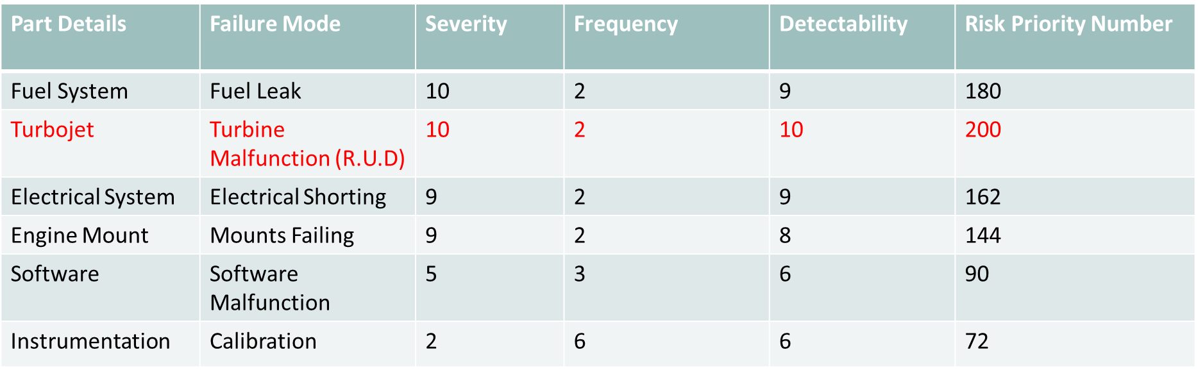
Table 24 : Ranking of Failure mode
For each component, the failure modes and their resulting effects on the system were recorded.
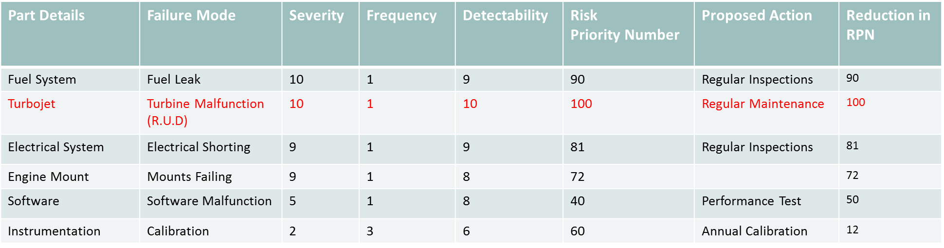

Table 25 : Ranking of failure mode action 1

Table 25 provides critical analysis on reducing failure modes by proposed action. Early identification of all critical system failure modes can be eliminated or reduced through design modification for high probability of successful operation and safety.

Bill of Materials
Materials | Part Number | Quantity | Provider | Material Cost PPU | Cost $
Rubber End Cap 2"x2" | FWMAT604R | 4 | fullcirclepadding.com | 3.75 | 15
Plastic Frame Cap 2"x2" | FWP280 | 4 | fullcirclepadding.com | 1.5 | 6
1"x1"x72" Square Steel Tubing 1/16" Wall Thickness |  | 3 | Home Depot | 21.64 | 64.92
2"x2" Square Steel Tubing |  |  |  |  | 0
1/4" Steel Plate |  |  |  |  | 0
0.22"x24"x48"Plexiglass |  | 2 | Lowes |  | 0
1/2" Steel Rod |  | 1 | Home Depot | 5.77 | 5.77
1/4" Steel Rod |  | 1 | Home Depot | 4.63 | 4.63
1/4"x2" Bolt/Machine Screw |  | 4 | Home Depot | 0.38 | 1.52
1/4"x2.5" Zinc Plated Hex Bolt 20 tpi |  | 28 | Home Depot | 0.20 | 5.6
1/2" Hot Dipped Galvanized Cut Washer |  | 16 | Home Depot | 0.33 | 5.28
High Strength Steel Nylon Insert Locknut pkg of 10 | 97135A250 | 1 | Mcmaster-Carr | 4.31 | 4.31
1/4" Nut 20 tpi |  | 32 | Home Depot | 0.06 | 1.92
1/4" Washer |  | 50 | Home Depot | 0.12 | 6
1-Gang Horizontal or Vertical Mount Weatherproof Flip Lid Cover/Duplex Kit |  | 1 | Home Depot | 8.79 | 8.79
14/3 Stay Plug Extension Cord - Red - 100ft |  | 1 | Home Depot | 35.93 | 35.93
14" Accuride Full Extension Ball Bearing Drawer Slide Pair |  | 1 | Home Depot | 29.63 | 29.63
2-1/2" Zinc-Plated Barrel Bolt |  | 2 | Home Depot | 2.97 | 5.94
1/2" Shaft 63" Hardened Rod Linear Motion Shaft |  | 2 | VXB Ball Bearings | 35.88 | 71.76
Linear Systems WH8A 1/2" Shaft Support | WH8A | 6 | VXB Ball Bearings | 18.95 | 113.7
NB Systems TWA8UU 1/2" Ball Bushing Block Linear Motion | TWA8UU | 4 | VXB Ball Bearings | 62.95 | 251.8
1 Gal Fuel Tank |  |  |  |  | 0
PTFE tubing for fuel line
Pressure Transducer Tubing |  |  |  |  | 0
Sorbothane | 8514K53 | 2 | McMaster-Carr | 7.64 | 15.28
4" Rigid Non-Marking Rubber Caster |  | 2 | Home Depot | 9.97 | 19.94
4" Polyurethane Caster With Brake |  | 2 | Home Depot | 9.97 | 19.94
1" x 48" Steel Sch. 40 Black Pipe |  | 1 | Home Depot | 16.52 | 16.52
Load Cell | LC302-50 | 3 | omega.com | 321 | 963
Flow Meter |  |  |  |  | 0
Pressure Transducer |  | 2 | omega.com | 367 | 734
Emergency Stop Corrosion-Resistant Washdown Enclosure-Mounted Switches | 6785K21 | 2 | McMaster-Carr | 40.54 | 81.08
JetCat FOD Screen | JC-A1047 | 1 | dreamworksrc.com | 59.99 | 59.99
Pitot Probe | G2228301 | 1 | zoro.com | 61.6 | 61.6
JetCat Turbine Oil 12 Pack | JC-A3001-12 | 1 | dreamworksrc.com | 143.4 | 143.4
USB-USB Cable |  | 1 | Home Depot | 6 | 6
DAQ |  |  |  |  | 0
DAQ Cable |  |  |  |  | 0
Fuel |  |  |  |  | 0
Thermocouple |  |  |  |  | 0
Wheels | 43501 | 1 | http://www.rockler.com/workbench-caster-kit-4-pack | 59.99 | 59.99
Split Flange Assembly | 1W405 | 1 |  | 19.56 | 19.56
RBW8 NB 1/2" Resin Block Unit Motion Linear Bearing | RBW8 | 1 | VXB Ball Bearings | 29.43 | 29.43
1/2" Bearing Pillow Block Cast Housing Mounted Bearings | UCP201-8 | 2 | VXB Ball Bearings | 12.95 | 25.9
 |  |  |  |  | 0
 |  |  |  |  | 0
 |  |  |  |  | 0
 |  |  |  |  | 0
 |  |  |  |  | 0
 |  |  |  |  | 0
 |  |  |  |  | 0
 |  |  |  | Total Cost | 2894.13
Table 26 : Bill of Materials

Engineering Economics
 | Unit | Year
Labor Cost :  4 Production Employees  1 Engineer  1 Manager | $4,930 | $500,000
Material Cost | $2,500 | $250,000
Production Cost | $7,500 (Rounded)
Distributor Price (100% Profit) | $15,000 | $1,500,000
Retail Cost (100% Profit) | $30,000

*Competitive Retail Cost : $68,500 – 121,000
Table 27: Engineering Economics

The above chart shows the retail cost being $30,000 when taking into account labor cost, material cost, production cost and distributor cost. The final retail cost compared to competitors is significantly lower. This shows our sweet spot in that we would offer a lower quality product but compete substantially in price.

Summary
Our team began our project with market analysis. This allowed us to identify our major competitors. In doing so we were able to investigate how our competitors designed their products to satisfy the needs and wants of the customer. Through the process of QFD we were able to identify the “sweet spot” for our design criteria.
From there we moved on to the design selection. In this the design was broken down into manageable sub-functions. Through the process of brain storming, design constraints and concept variants were developed. With these the choices were methodically compared until a final selection had been made for each sub-function.
In engineering analysis key answers were sought to questions about design reliability and functionality. What are the mode shapes of vibration of the structure? What is the accuracy of the system? Will the structure withstand the forces it is being submitted to? These are all things we tried to answer.
Finally we reached the economic analysis. Here we sought to see what expenses the company would incur in manufacturing this test stand. In the end we seek to bring our test stand to market at a price of $30,000. This is less than half of what our closest competitor is selling their product at.

References
- By Continuing to Browse the Site You Are Agreeing to Our Use of Cookies. Find out More Here. "PA Hilton Engineering Teaching Equipment. Technical Training Equipment. Vocational Equipment." PA Hilton Engineering Teaching Equipment. Technical Training Equipment. Vocational Equipment. N.p., n.d. Web. 22 Sept. 2016. <http://www.p-a-hilton.co.uk/>.
- "Emprise Corporation." ZoomInfo. N.p., n.d. Web. 29 Sept. 2016. <http://www.zoominfo.com/c/Emprise-Corporation/17303129>.
- "GDJ Inc." ZoomInfo. N.p., n.d. Web. 22 Sept. 2016. <http://www.zoominfo.com/c/GDJ-Inc/15712337>.
- Group, JPS Design. "Welcome." GDJ, Inc. N.p., n.d. Web. 22 Sept. 2016. <http://www.gdjinc.com/>.
- "Integrated Flow Systems Llc." ZoomInfo. N.p., n.d. Web. 29 Sept. 2016. <http://www.zoominfo.com/c/Integrated-Flow-Systems-Llc/343510787>.
- N.p., n.d. Web. <http://www.p-a-hilton.co.uk/teaching-equipment-for-sale.php?buy=327&addid=327>.
- "P A Hilton." ZoomInfo. N.p., n.d. Web. 22 Sept. 2016. <http://www.zoominfo.com/c/P-A-Hilton/348843272>.
- P.A. Hilton. N.d. Jet Propulsion Test Stand P372 Specs. England, Hampsire Stockridge.
- Turbine Technologies. 2014. Turbo gen. Chetek, Wisconsin.
- Turbine Technologies- Creating Educational Lab Equipment For Tomorrow's Engineers. "Controls Lab ." Turbine Technologies. N.p., n.d. Web. 22 Sept. 2016. <http://www.turbinetechnologies.com/>.
- Turbine Technologies Inc. 2014. MiniLab Specs. Chetek, Wisconsin.
- "Turbine Technologies Inc." ZoomInfo. N.p., n.d. Web. 22 Sept. 2016. <http://www.zoominfo.com/c/Turbine-Technologies-Inc/348276565>

